SAVE OUR NEIGHBORHOOD GROUND WATER; 10/01/2018
REJECT THE UNDERDRAINS
A longtime friend of ours who lives in Northshore came by our house today and told us the frightening condition of Rockport and Echo Reservoirs. He goes by them a couple times a week. He said the water line at Rockport is the lowest he has seen in 26 years. A few days ago is the first time that he saw the stone foundations of the town of Rockport before it was flooded to create this C.U.P. Reservoir c.1954.
Ten years ago or so Summit County Mountain Regional Water had to find a source for water to our subdivision. Canyons construction of homes, condos and golf course has greatly diminished the local supply. Upon re-drilling the well on the big lake peninsula down to 500 feet no potable water was found. After drilling at Bear Hollow for a number of years and at Sun Peak for more years, the best that could be done was to build a 20 mile pipeline from Rockport to Silver Springs.
This is why Mike's report that Rockport is below 29% capacity is a concern to Silver Springs. Every water organization and department, local and state, that I talked to are alarmed that our HOA is seeking to expand and reopen underdrains that will discharge our existing precious underground water out of our subdivision. Weather records show that drought and diminished precipitation have been steadily affecting our area since 1980. Temperatures are steadily increasing as is the damaging UV index. No one knows how long this will continue. What we do know is that we live in an alpine desert and that new home construction is a perpetual activity here, requiring more and more water connections.
If we care anything about our property, mature trees, our yards, streams and lakes then we have to do everything we can to preserve this natural resource within our subdivision.
On March 5, 2018 after a board meeting, Rick Hovey challenged me to record the 2008 Articles of Incorporation that had been passed by 82% of our Homeowners. I had not recorded them with the State because of the turmoil created by the ambush of the HOA's 2008 Annual Meeting by two Members and their attorney Lincoln Hobbs. After Hovey carried on so loudly I did record these Articles, they contain the Owners position that they do NOT want to pursue or take on the liability of the underdrains. Additionally, Owners do not want to pass the draft Richards Law CCRs.
I have been actively working to bring information to our Neighbors. The board website has only one side of the underdrains story. There is a far more compelling history and conclusion for their demise on the https://www.silverspringscommunity.com/underdrain-system/ pages.
I hope each Member and neighbor will support the REJECTION of the underdrains-focused CCRs drafted by the underdrains committee/ CCRs rewrite committee’s dual chairman, and John Richards Law. Your support is greatly appreciated. I commend anyone who gets involved for the good of our neighborhood. I will, therefore, continue to report what I learn and know to each neighbor in an effort to avoid a disaster of immense complexity and costs, liabilities and dimensions that will destroy our mountain homes values and peaceful enjoyment
Most sincerely,
Lucy Archer 10/ 01/2018
This letter is also posted at: https://www.facebook.com/SilverSpringsCommunityUT/
http://rockport.lakesonline.com/Level/ https://ut.water.usgs.gov/ https://water.utah.gov/Planning/SWP/Weber_riv/WeberRiverBasinPlan09.pdf

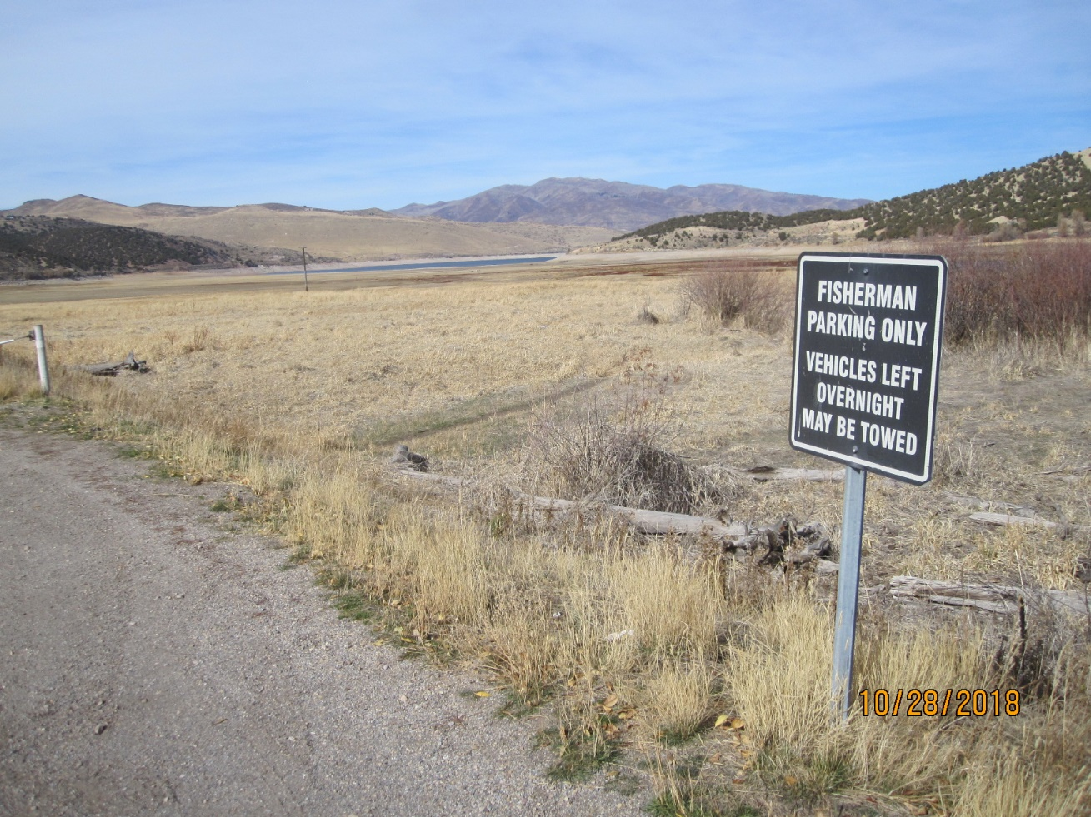
Rockport Reservoir has receded over a mile from where we could go fishing a few years ago.

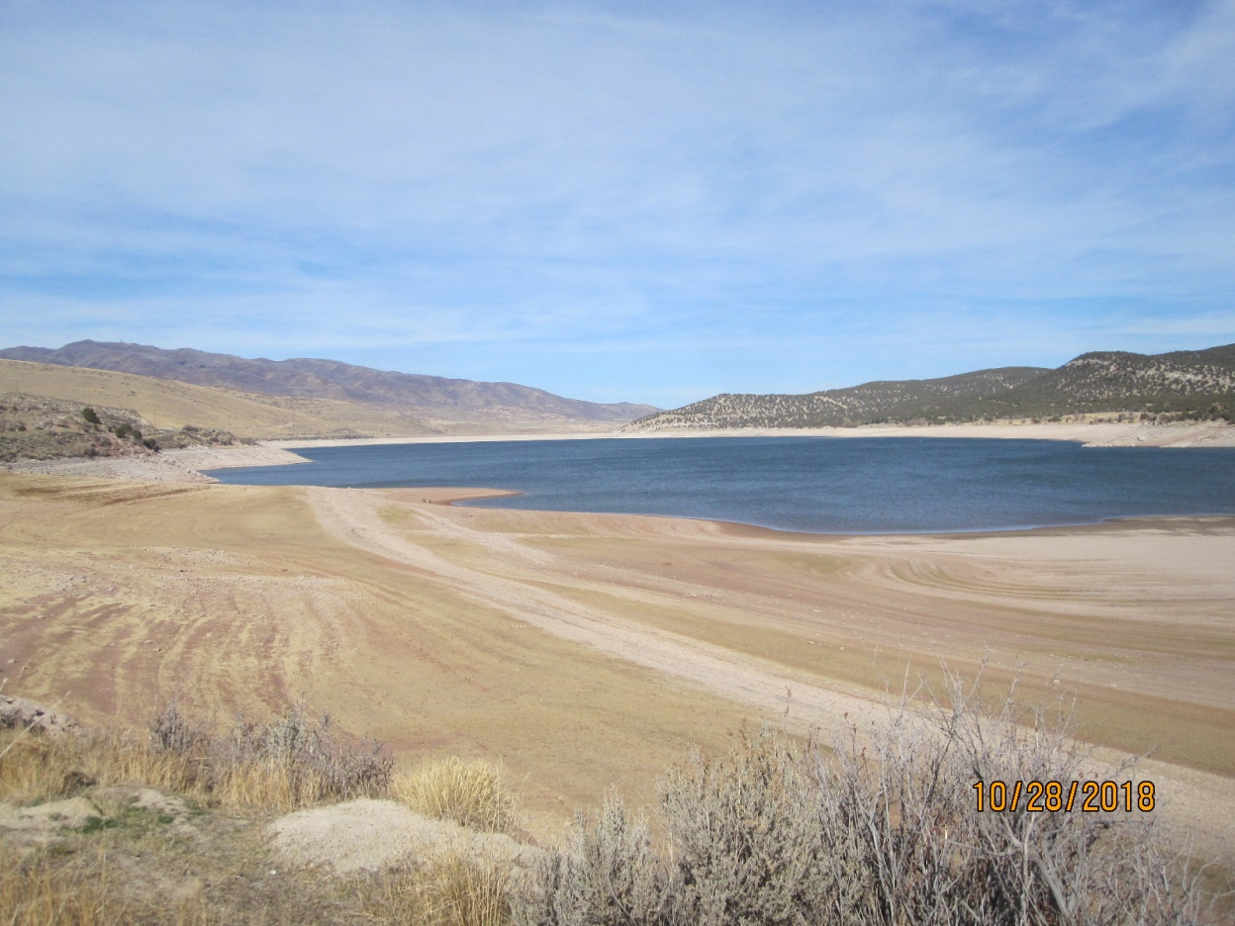
For the first time in 26 years City of Rockport building foundations are visible.
Water Capacity for this Reservoir, the SSSF Community water source is less than 29%.

